**I. Pizza Menu CRUD APIs**

Objective: To implement the REST endpoints to manage menu for any pizza store.

1. POST /menu

**Output:**

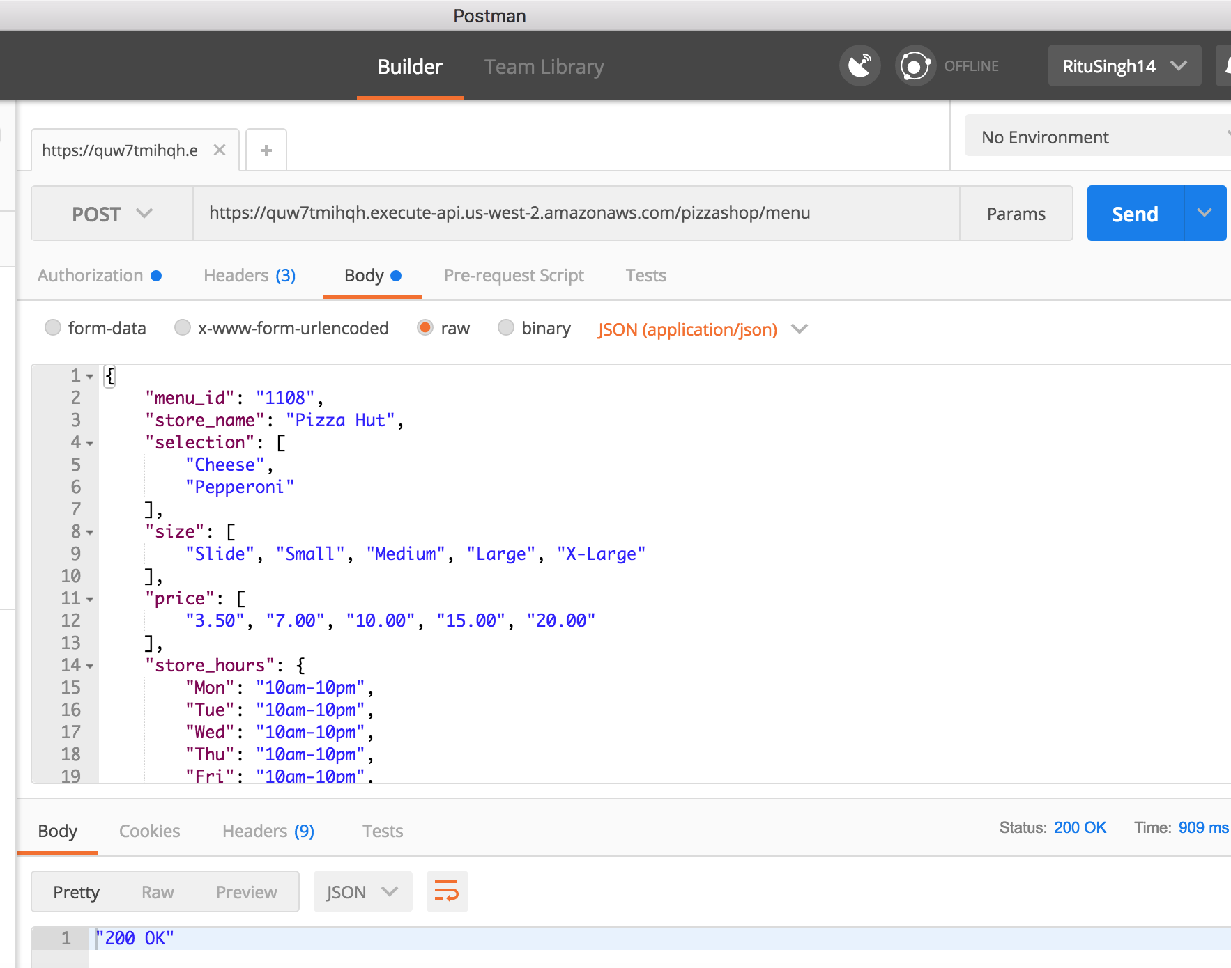

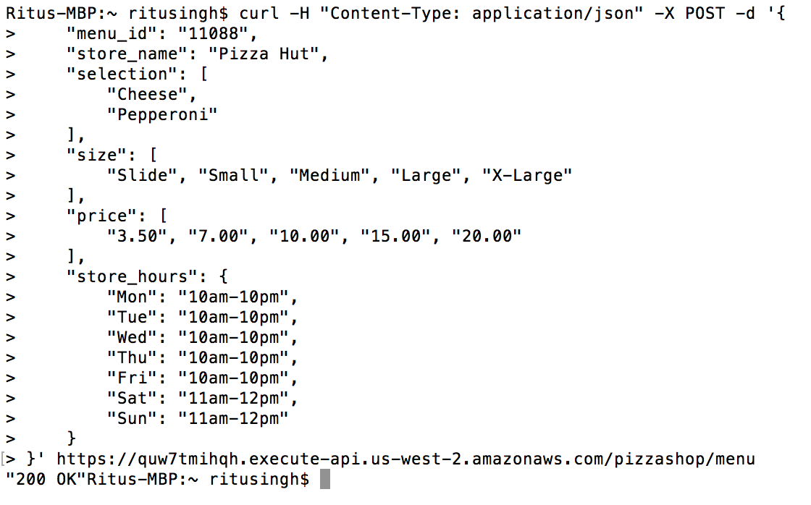

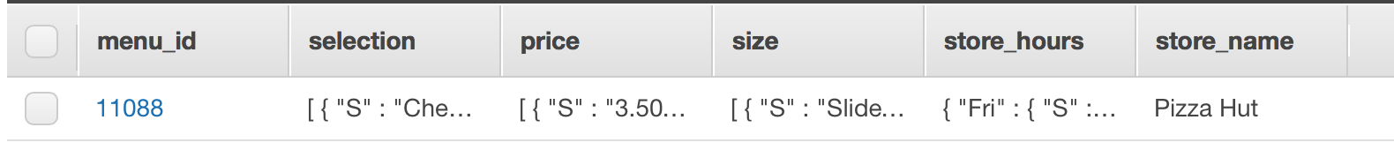



1. DELETE /menu/{menu-id}

**Output:**

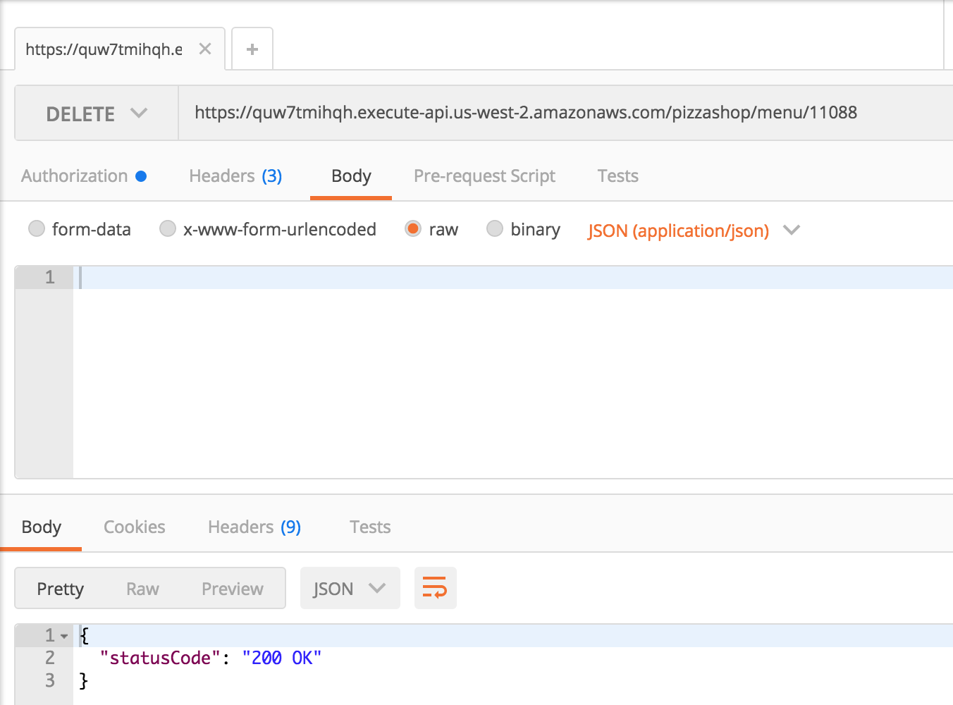



1. GET /menu/{menu-id}

**Output:**

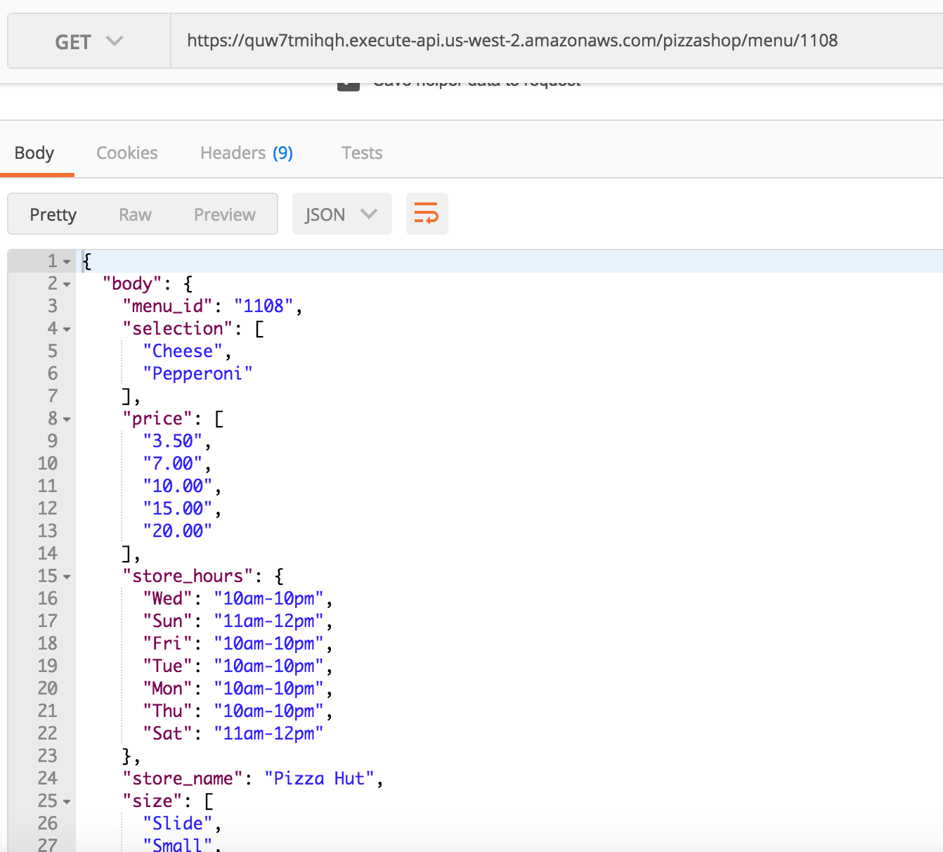

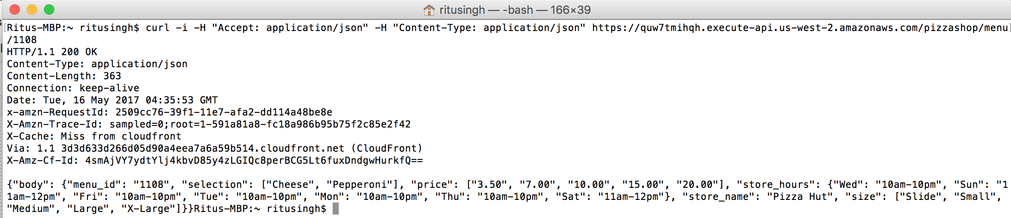

1. PUT /menu/{menu-id}

Request body sent is below: [The one in question has wrong format]

{

"menu_id": "10008",

"selection": [

"Cheese",

"Pepperoni",

"Vegetable"

]

}

Before PUT:



After PUT:



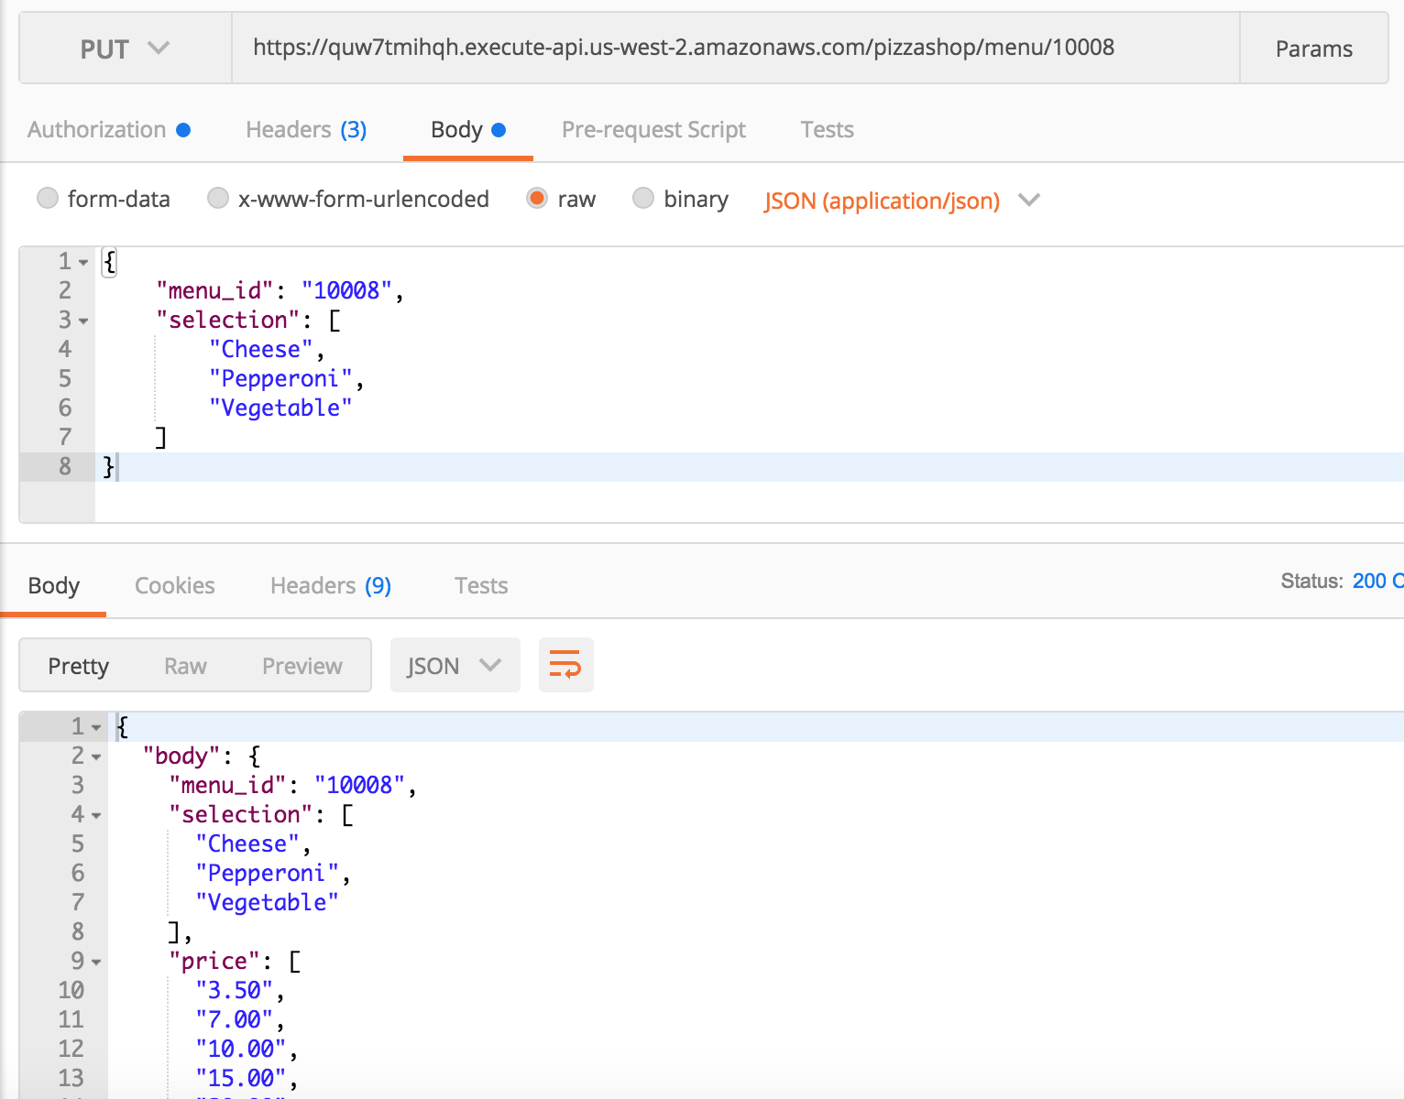

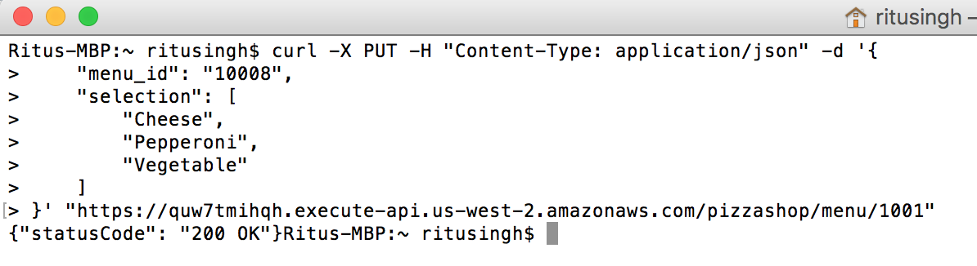

#### II. Pizza Order Processing APIs

1. POST /order

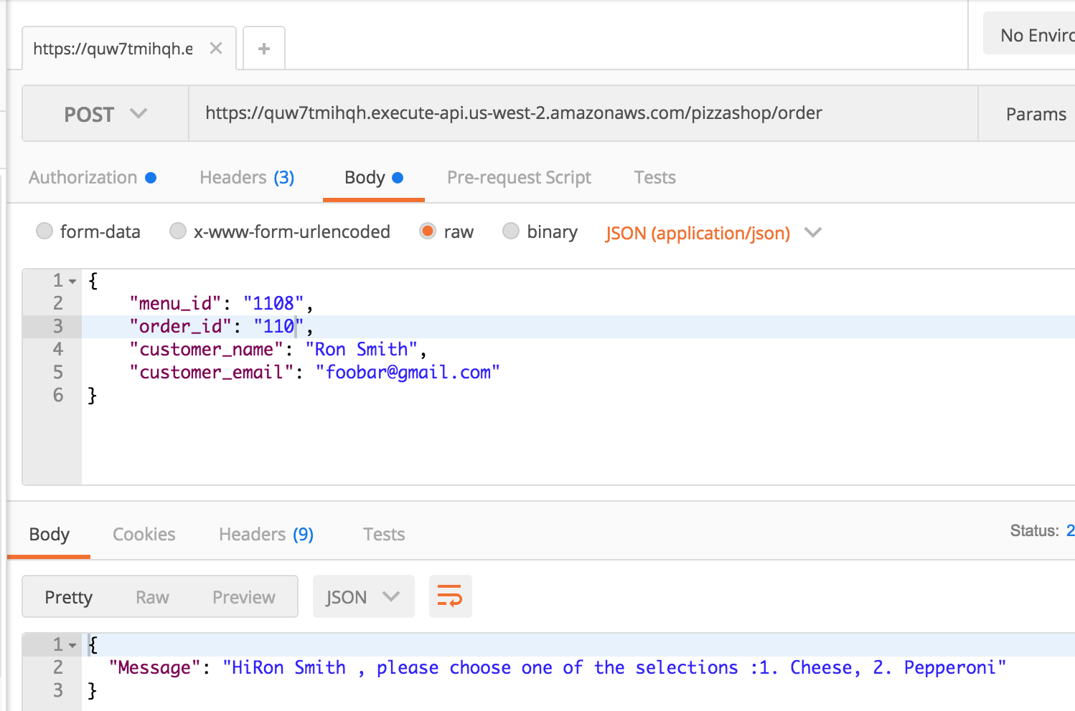

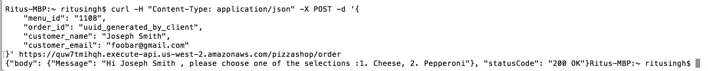



1. PUT /order/{order_id}

(the request body contains choice for selection.)

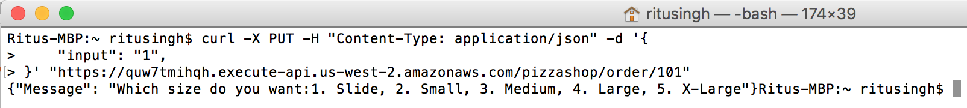

1. PUT /order/{order_id}

(the request body contains choice for size.)

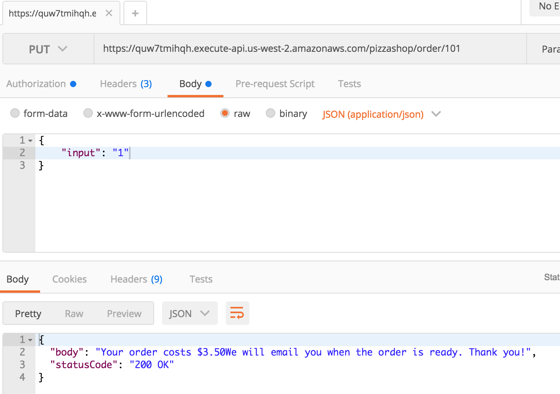

After run DB screenshot:

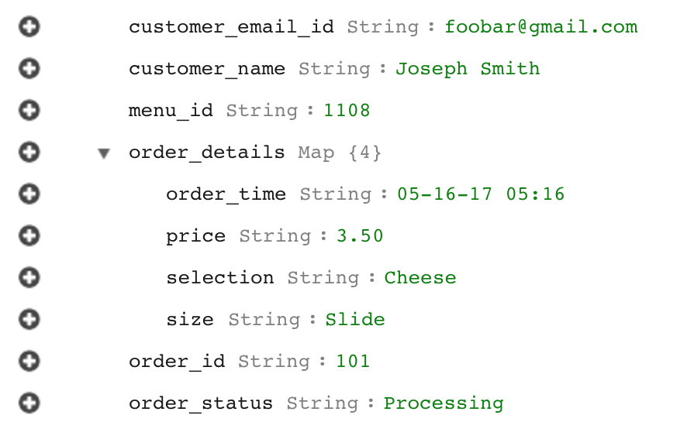

1. GET /order/{order-id}

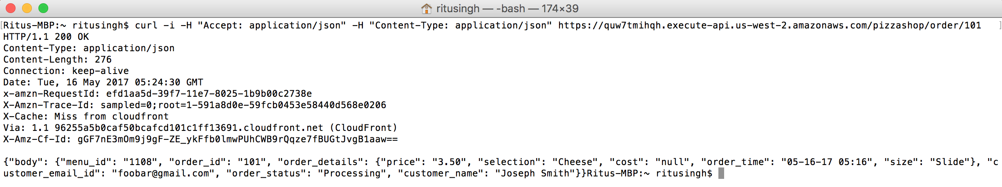

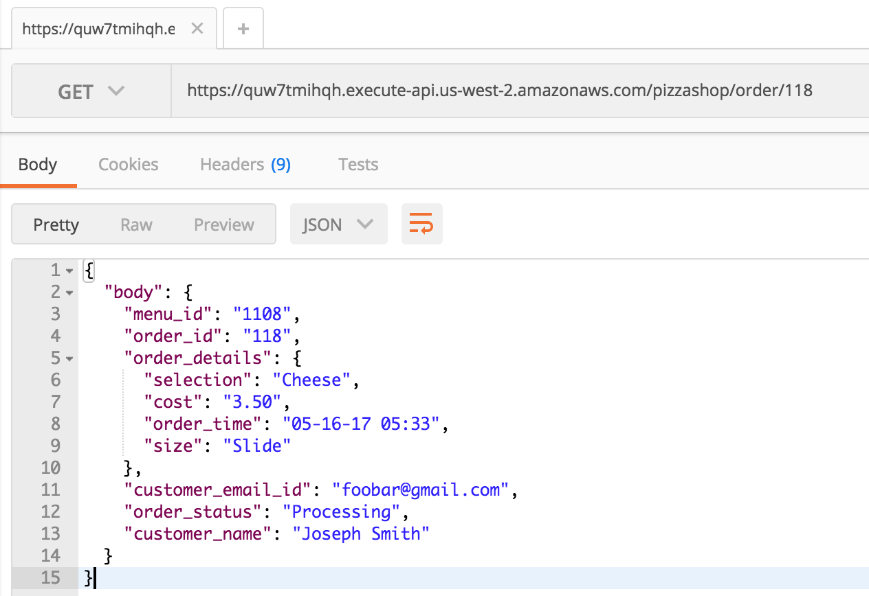

Lambda Functions used:

